**Department of Health & Human Services**

**Centers for Medicare & Medicaid Services**

**Office of Clinical Standards and Quality**

**Information Systems Group**

**7500 Security Boulevard**

**Baltimore, Maryland 21244-1850**

***Quality Net***

AWS RHEL 7 ADO Sever Provisioning Guide

Version 3.0

July 2017

Prepared by:

Ventech Solutions, INC.

# Table of Changes

|  |  |  |  |
| --- | --- | --- | --- |
| **Version** | **Date** | **Author** | **Description of change** |
| 1.0 | 4/19/2017 | Mike Rondello | Initial Document. Deployment Section |
| 2.0 | 6/1/2017 | Mike Rondello | Removed Post Deployment. Added Launch Content |
| 3.0 | 7/15/2017 | Mike Rondello | Changed name requirements and Notification section |
|  |  |  |  |
|  |  |  |  |

**Abstract**

This will provide an example on deploying am AWS EC2 Instance of Red Hat Enterprise Server 7. The procedure will utilize the HCQIS RHEL 7 Gold AMI template.

**Example Server**

This server will be deployed on the ADELE-ADO-1 SBX Environment in the APP Tier. It will be placed in AWS Availability Zone 1. It will also have an interface on the Management network. See deployment information below. These are all the pieces of information needed to deploy a server. This information should be gathered in an SBR prior to every server being built.

|  |  |
| --- | --- |
| **Data Element** | **Value** |
| **AMI** | RHEL_GOLD_VERSION_9 |
| **Virtual Private Cloud (VPC)** | ADELE-ADO1-SBX |
| **Subnet (FUNCTIONAL)** | ADELE-ADO1-SBX-APP-AZ1 |
| **Subnet (MANAGEMENT)** | ADELE-ADO1-SBX -MGT-AZ1 |
| **User Data** | See page 4 |
| **Security Group (MANAGEMENT)** | ADELE-ADO1-SBX-app_data_mgt-sg |

**Server Deployment**

1. Under the EC2 Dash board click the **Launch Instance** button. Choose My AMIs on the left. Make sure the “**shared with me**” check box is checked.

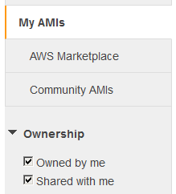

1. **AMI:** Select the most current RHEL_GOLD Image.

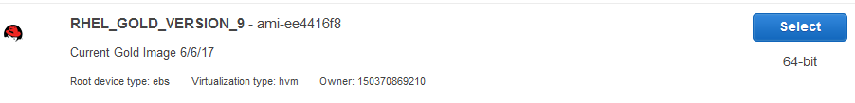

1. **INSTANCE TYPE:** Choose your instance type. This will be determined by the server need. Click **Next: Configure Instance Details**. For this example we chose **m3.medium**.



1. **NETWORK / BOOT SETTINGS**: Under **Network** and **Subnet**, choose your **VPC** and **FUNCTIONAL** Subnet. This is the network for (WEB/APP/DB). On the OS this is network interface (eth0). **Do not try to auto-assign Public IP.** Keep the default [**Use subnet setting (Disable)**].

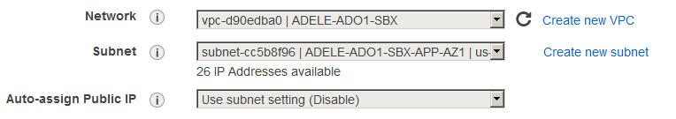

1. Under the **IAM Role** section. Choose the following role**: EC2-Hostname.** If this role is not applied, the server will not complete post deployment tasks. This role creates permissions for the first-boot.txt



1. Expand **Network Interfaces**, and click **Add Device** button to add another interface (**eth1**) on the **MANAGEMENT** subnet. Select your MANAGEMENT subnet in the drop down list**.** This is the network required to log into the server and connect to HCQIS Enterprise Services**. Note if for any reason you have to return to this section, the console will change the eth1 network to be identical to the eth0 network. It is a quirk. Remember to set it back.**

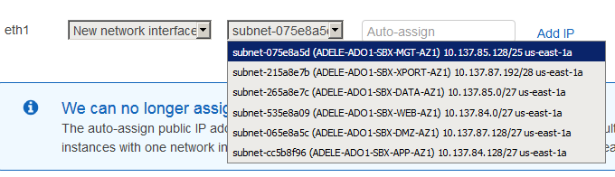

1. Scroll down and expand **Advanced Details**. Click the **user data** “**as text**” radial button. Paste the following script into the text box**. This is critical. If the script is not run at boot, there is no way to connect to the server.**

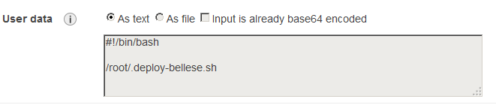

**Copy Text Box**

#!/bin/bash

/root/.deploy-bellese.sh

1. **STORAGE:** Click the **Next: Add Storage** button. Here you can add another disk for data. Make sure the device is **/dev/sdb.** Make sure the “**delete on termination**” check box is checked. The secondary disk will be mounted as **/app** in the OS.

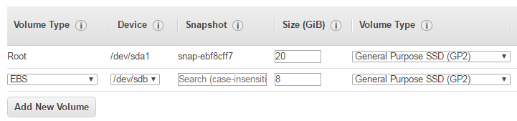

1. **NAME:** Click the **Next: Add Tags** button. This will allow you to set the name of the instance and other tags. Click **Add Tag** button and type in “**Name**” to create a name tag. Add the name of the server in the **Value** field. **Formerly this name would be used to set the hostname of the server. This is no longer the case. A HCQIS host name will be auto generated and set in the HCQISName Tag.**

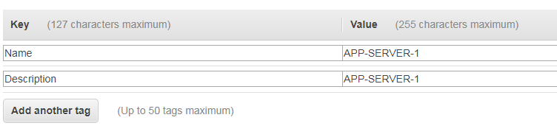

1. **SECURITY GROUPS:** Click the **Next: Configure Security Group** button. Choose the group by selecting the “**Select an existing security group**” radial button. This will expand a list to choose the group. Choose the security group for your MANAGENT (WEB/APP/DB) subnet. This will bind the security group to both interfaces. **DO NOT ATTEMPT TO CREATE A NEW SECURITY GROUP. Notice there are separate security groups for (APP/DB) and (WEB)**

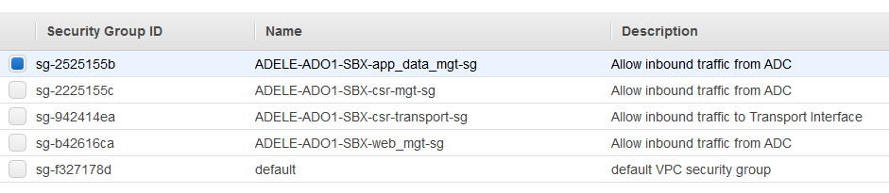

**NOTE:** This will attach the management security group to both interfaces on the server. In order to use the functional interface on the server, a security group of your choosing must be created and then manually attached to the ENI for interface (eth0).

1. **Launch and Key Pair:** Click the **Review and Launch** Button. This will show a page that has all the details of the instance. Click the **Launch** button. This will open up a dialog box asking you to choose a key pair to bind to the machine. Choose not to use a key pair

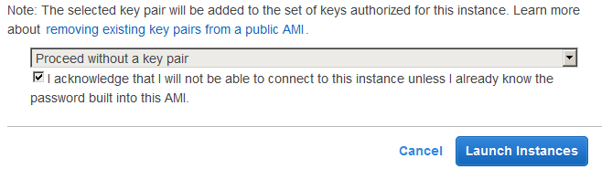

1. Once the EC2 instance has been launched and is ***running***, find it in the EC2 Running instance console. Click on the **eth1** link in the instance description. It will pop up a dialog box. This is how you view your IP addresses for the server. To connect to the server, choose the IP address of the **eth1** interface. SSH to that IP with your HCQIS credentials ([username@qnet.qualnet.org](mailto:username@qnet.qualnet.org)). It usually takes about 10 minutes to completely boot and configure the server.

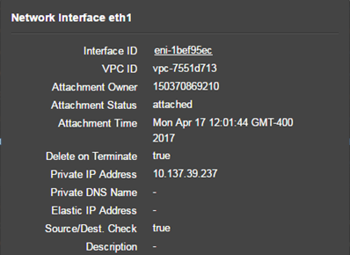

1. **Deployment Status**. To validate that the server has completed the post deployment, you can reference the **DeployStatus** tag on the instance **Tags** page. There will be a status of **complete** when the deployment is finished. You can also see the value to which your **HCQISName** and server host name is set.

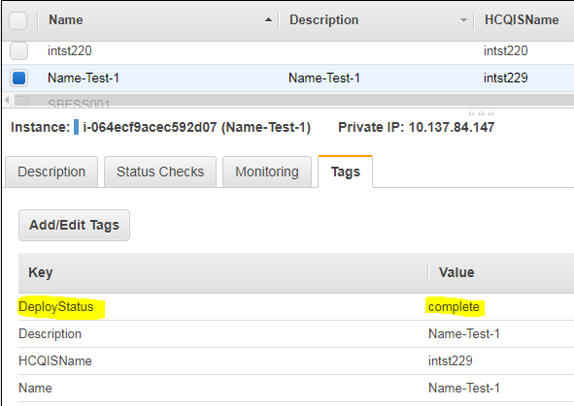

1. Within ~30 minutes of launch, your new host will be entered into DNS. To connect to the host, you must use the **hostname-mgt.hcqis.org** DNS name. If DNS has not been set, you can still use the MGT IP to connect to the server.

ssh hostname-mgt -l username@qnet.qualnet.org

ssh 10.137.39.237 -l username@qnet.qualnet.org

**Putty/Tectia**

If you use a program such as putty or tectia the username format is as follows (qnet\username)